

ASUMBI GIRLS’ 2025 PREDICTION
CONFIDENTIAL KCSE EXAM
231/1
BIOLOGY
PAPER 1 (THEORY)
TIME: 2 HOURS

NAME……………………………………………………….
SCHOOL……………………………………………… SIGN………………………..
INDEX NO………………………………………. ADM NO……………………

(Kenya Certificate of Secondary Education)

INSTRUCTIONS TO CANDIDATES
- Write your name and admission number in the spaces provided.
- Answer all questions in the spaces provided.
- Candidates should check the question paper to ascertain all the pages are printed as indicated and no questions are missing.

FOR EXAMINERS USE ONLY
QUESTIONS | MAXIMUM SCORE | CANDIDIATES SCORE
1 -30 | 80

Answer all questions in the spaces provided.
- Name one chemical used to immobilize highly mobile animals during collection in field for study (1 mark)
……………………………………………………………………………………………

- Give a name for a branch of biology which deals with; (2 marks)
- Study of cells
………………………………………………………………………………………………
- Study of internal structure of living organisms.
………………………………………………………………………………………………

- Conjugated proteins are proteins which combine with non- protein compound. Name non-protein compound in the following conjugated proteins (2 marks)
- Mucus
……………………………………………………………………………………………
- Haemoglobin
……………………………………………………………………………………………

- State two differences between smooth muscles and skeletal muscles (2marks)
………………………………………………………………………………………………
………………………………………………………………………………………………
………………………………………………………………………………………………
……………………………………………………………………………………………..

- Study the diagram below and answer questions that follows
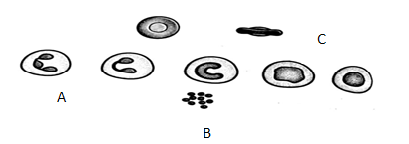
C
A
B

- Highlight the type of tissue illustrated (1mark )
……………………………………………………………………………………………

- Name the cells labeled ( 2marks)
A-………………………………………………………………………………………
B-…………………………………………………………………………………………
- Give one adaptation of cell C to its function ( 1mark)
………………………………………………………………………………………………
………………………………………………………………………………………………

- The diagram below shows a transverse section of a plant organ
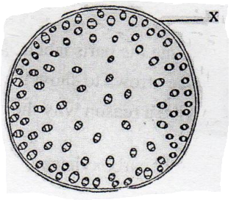
- Name the plant organ from which the section was obtained (1 mark)
………………………………………………………………………………………………
- (i) Name the class of the plant from which the plant organ was obtained. (1 mark)
………………………………………………………………………………………………
(ii) Give a reason for your answer in (b) (i) above. (1 mark)
………………………………………………………………………………………………
………………………………………………………………………………………………
- Name the part labeled X (1 mark)
………………………………………………………………………………………………

- State a characteristic that is common to all cervical vertebrae (1 mark)
………………………………………………………………………………………………
………………………………………………………………………………………………

- a) Name a protein and vitamin involved in blood clotting.
i) Protein. (1mark)
………………………………………………………………………………………………
ii) Vitamin (1mark)
………………………………………………………………………………………………
b) Explain why blood is not normally used for transfusion after one month. (1mark)
………………………………………………………………………………………………
………………………………………………………………………………………………
………………………………………………………………………………………………

- The diagram below represents a section of the human brain.
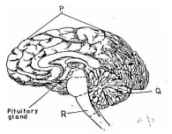
i) Name the structure labelled P . (1marks)
………………………………………………………………………………………………
ii) State one function of the part labelled R. (1mark)
………………………………………………………………………………………………
………………………………………………………………………………………………

iii) Give a disease which is caused by bacteria infection on brain membranes (1 mark)
………………………………………………………………………………………………

- The reaction represented by the equation below occurs in the body.
Enzyme Y
Hydrogen peroxide Oxygen + Water
(a) Name enzyme Y. (1mark)
………………………………………………………………………………………………
(b) Name an organ in the body where the reaction occurs. (1mark)
………………………………………………………………………………………………

- The diagram below represents a neuro-junction/synapse
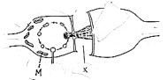
- Name the:
i) Structure labeled M. (1mark)
……………………………………………………………………………………………
………………………………………………………………………………………………

ii) Enzyme responsible for reconstitution of transmitter substance labeled X. (1mark)
………………………………………………………………………………………………
……………………………………………………………………………………………
………………………………………………………………………………………………
- On the diagram, show the direction of the nerve impulse transmission. (1mark)

- The graph below represents the growth of animals in a certain phylum. Study it and answer the questions that follow
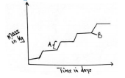
- Name the type of growth pattern shown on the graph (1mark)
………………………………………………………………………………………………

- Identify the process represented by letter B (1mark)
………………………………………………………………………………………………

- Name the hormone responsible for the process in (b) above (1mark)
………………………………………………………………………………………………

- Study the diagram below and answer the questions that follows
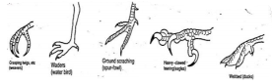
- What type of evolution is illustrated by the limbs (1mark)
………………………………………………………………………………………………
- What does the origin of the limbs suggest about the ancestry of these animals (1mark)
………………………………………………………………………………………………

- Compare the blood in the umbilical artery and umbilical vein in placenta (2marks)
………………………………………………………………………………………………
………………………………………………………………………………………………
………………………………………………………………………………………………
………………………………………………………………………………………………

- Carefully study the figure which rotates making one resolution in 15 minutes. A seedling
With a straight radicle and plumule was attached to the apparatus as shown below.
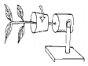
- What is the name of the apparatus shown (1mark)
………………………………………………………………………………………………

- Make a drawing of how the seedling might have appeared after one week. Explain (2mark)

- State the type of response being investigated in the experiment above. (1mark)
………………………………………………………………………………………………
………………………………………………………………………………………………

- (a) Why is sexual reproduction important in evolution of plants and animals (1mark)
………………………………………………………………………………………………
………………………………………………………………………………………………
(b) The calyx cells of a certain plant has 22 chromosomes. State the number of chromosomes present in plants (2marks)
(i) Endosperm
………………………………………………………………………………………………
………………………………………………………………………………………………

(ii) Ovule cell
………………………………………………………………………………………………
………………………………………………………………………………………………

- The diagram below shows the internal structure of the mammalian ear
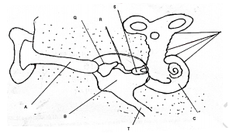
- Name the part labeled Q (1mark)
………………………………………………………………………………………………

- Explain what would happen if the part labeled T is blocked (2marks)

………………………………………………………………………………………………
………………………………………………………………………………………………
………………………………………………………………………………………………

- (a) State the functions of olecranon process. (2marks)
………………………………………………………………………………………………
………………………………………………………………………………………………
………………………………………………………………………………………………

(b) Which type of joint is found at the articulation of:

(i) Pelvic girdle and femur (1mark)
………………………………………………………………………………………………
(ii) Humerus and ulna (1mark)
……………………………………………………………………………………………

- State three adaptations of aquatic plants to photosynthesis. (3 marks)
………………………………………………………………………………………………
………………………………………………………………………………………………
………………………………………………………………………………………………
………………………………………………………………………………………………
………………………………………………………………………………………………

- Distinguish between haemolysis and plasmolysis. (2marks)
………………………………………………………………………………………………
………………………………………………………………………………………………
………………………………………………………………………………………………
………………………………………………………………………………………………

- State two adaptations of respiratory surface to gaseous exchange (2marks)
………………………………………………………………………………………………
………………………………………………………………………………………………
………………………………………………………………………………………………

- State two roles of hydrochloric acid in the digestion of food. (2marks)
………………………………………………………………………………………………
………………………………………………………………………………………………

- a) Name the blood vessels that link arterioles with venules (1mark)
………………………………………………………………………………………………
b)How are the blood vessels above suited to carry out their functions (2marks)
………………………………………………………………………………………………
………………………………………………………………………………………………
………………………………………………………………………………………………

- Explain how the following adaptations will reduce the rate of transspiration. (2marks)
    - Sunken stomata
………………………………………………………………………………………………
………………………………………………………………………………………………
………………………………………………………………………………………………

    - Leaf folding
………………………………………………………………………………………………
………………………………………………………………………………………………
………………………………………………………………………………………………

- a) Name two structures for gaseous exchange in amphibians (2marks)
………………………………………………………………………………………………
………………………………………………………………………………………………

b) What is the effect of relaxation of diaphragm muscles during breathing in mammals? (2marks)
………………………………………………………………………………………………
………………………………………………………………………………………………
………………………………………………………………………………………………

- The equation below represents a process that occurs in plants.
B
C₆H₁₂O₆ + C₂ H₅ OH +Energy
a) Name the process (1mark)
………………………………………………………………………………………………
b) Name the product B (1mark)
………………………………………………………………………………………………
c) State the economic importance of this process (2marks)
……………………………………………………………………………………………
………………………………………………………………………………………………

- State the role of the following bacteria in the Nitrogen cycle.
(i) Nitrosomonas……………………………………………………………………(1mark)
(ii) Nitrobacter………………………………………………..……………………..(1mark)

- State the structures that adapt the fish for: (2marks)
a) Forward movement…………………………………………………………………………….
b) Fast movement…………………………………………………………………………………

- Name the organelled that:-
- Manufacture and transport lipids and steroids in a cell. (1mark)
………………………………………………………………………………………………………
- Contain enzymes that are capable of destroying old damaged cells. (1mark)
………………………………………………………………………………………………
- Form cilia and flagella in cells that have them. (1mark)
………………………………………………………………………………………………

- A patient blood was found to have the parasite below:
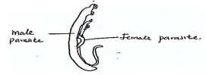
- Name the parasite; (1mark)
………………………………………………………………………………………………

Name the disease the patient was suffering from; (1mark)
………………………………………………………………………………………………

- State one way the above disease can be controlled. (1mark)
………………………………………………………………………………………………
………………………………………………………………………………………………

THIS IS THE LAST PAGE PRINTED.

